**Mirror Tree:-**

Given a Binary Tree, convert it into its mirror.  
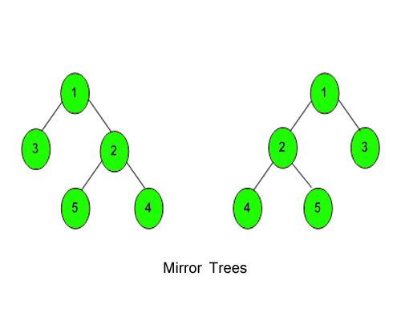

**Example 1:**

**Input:**

1

  / \

  2 3

**Output:** 2 1 3

**Explanation:** The tree is

   1   (mirror) 1

/  \   =>      /  \

3    2          2   3

The inorder of mirror is 2 1 3

**Example 2:**

**Input:**

10

  / \

  20 30

  / \

  40 60

**Output:** 30 10 60 20 40

**Explanation:** The tree is

      10               10

   /    \  (mirror) /    \

  20    30    =>   30    20

  /  \                /   \

 40  60                 60   40

The inroder traversal of mirror is

30 10 60 20 40.

**Your Task:**  
Just complete the **function mirror()**that takes **node**as **paramter**and convert it into its mirror. The printing is done by the driver code only.  
**Expected Time Complexity:**O(N).  
**Expected Auxiliary Space:**O(Height of the Tree).

**Constraints:**  
1 <= Number of nodes <= 100  
1 <= Data of a node <= 1000